Mapping Keys in Access Client

Click on top menu Communication and select configure

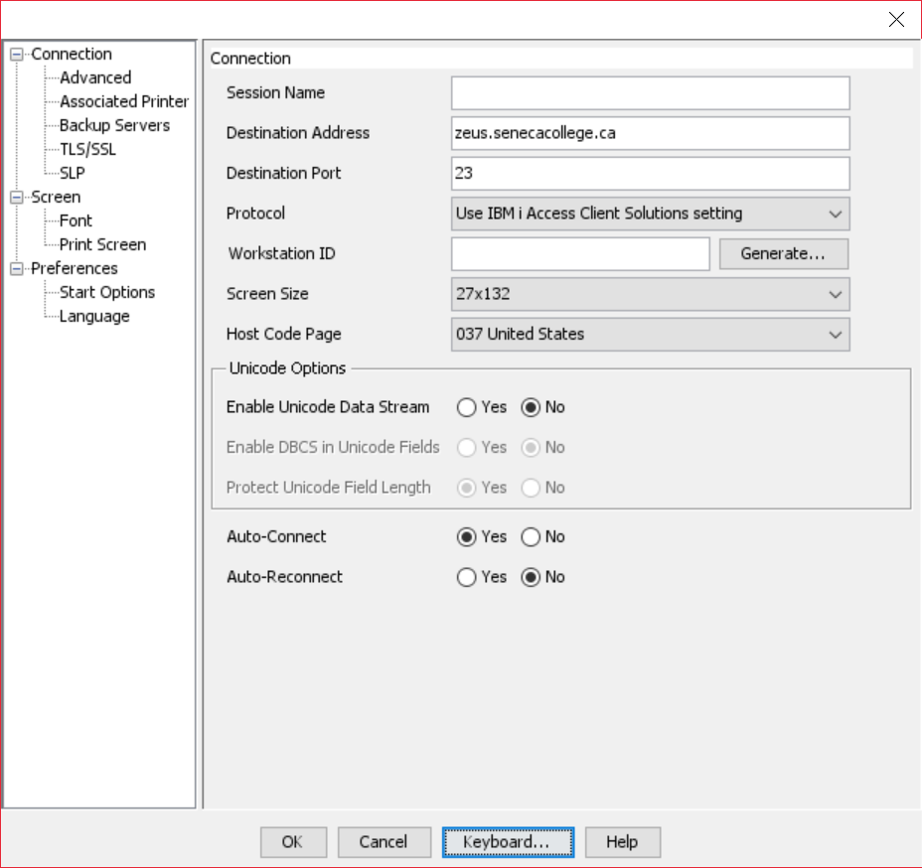

Click on Keyboard

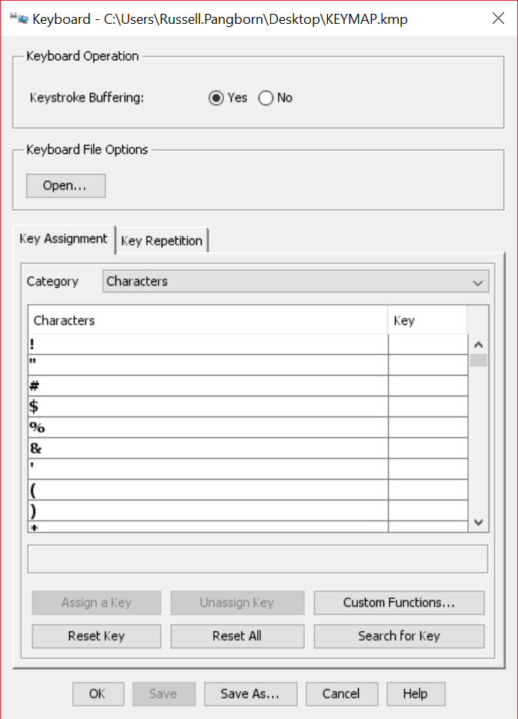

On Category, use the drop down menu to select for Host Functions and scroll down to Field exit.

It is already assigned a key combination, but you can click on Field exit and click on assign a key and they you can press CTRL+F and it will also be assigned to that key combination. That is the same as pressing the plus sign on the numeric keypad with the laptops in the lab.

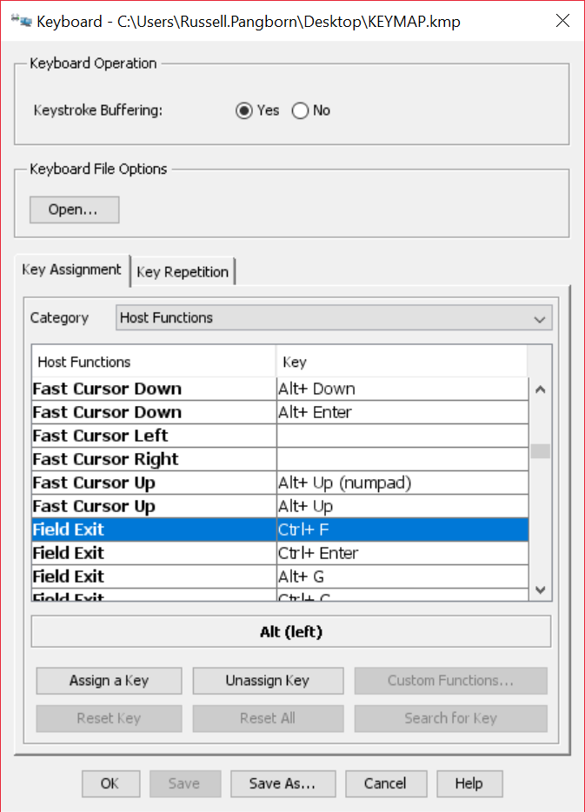

When you exit from everything you will get the following message

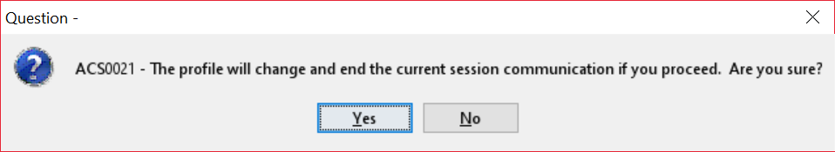

Say yes, sign in and you will have the new keyboard mapping available.